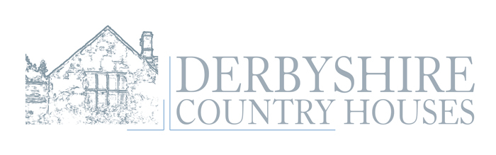
Thank you for choosing The Barn at Harthill Hall. Please find below information regarding your booking including swimming pool and therapist’s bookings.

Security Bond Payment
£500 is payable by bank transfer please use your booking reference, surname and name of property as reference, this needs to be received no later than three working days prior to your arrival, please email to confirm this has been actioned along with the bank account details for the refund which will be issued within 7 working days excessive cleaning charges and significant breakages (not a broken wine glass or two) will be deducted if necessary.
Derbyshire Country Houses Sort code 40-51-62 Account no 48670586
Key safe codes will only be sent on receipt of the email and payment.
Bedding Requirements
Floor plan below please email your requirements 14 days prior to arrival.
Pets
Up to 2 pets can be pre booked they should not be on the UK Government Dangerous dog list, this includes pit bull types or pit bull type crosses.
Arrival and Departure
You are welcome to arrive from 4pm, we ask that you have removed all your belongings, empty your bins and vacate the cottage fully no later than 10am.
Directions: https://www.google.co.uk/maps/place/Harthill+Hall/@53.1784336,-1.6607815,17z/data=!3m1!4b1!4m5!3m4!1s0x487a27b0a3b2eb17:0x7524abc68a35e6b5!8m2!3d53.1784336!4d-1.6585875

I will be your contact for the duration of your stay, if possible please avoid any contact after 4pm daily unless it really cannot wait until the morning. If you are celebrating a special occasion, have any special requests or require any further information, please let me know by email beforehand.

Kind regards

Lolly Miller (housekeeper)

Email: housekeeping@derbyshirecountryhouses.com Txt/WhatsApp: 07703 126635

Harthill Hall Bakewell Derbyshire DE45 1LH
www.derbyshirecountryhouses.com
vat no 684 3540 19

We operate a zero tolerance on rowdy parties we are a family site and if we deem the behaviour from your properties inhabitants unacceptable your hire will be terminated immediately.
We ask that you are respectful of our other guests and neighbours so no outside music/noise or anything that can cause a disturbance after midnight.
Room one Double / Twin One / Two Bunk Bed (Under 8 years)
Room two Double / Twin
Room three Double Fixed
Room four Double / Twin
Room five Double / Twin
Room six Double / Twin One / Two Bunk Bed (Under 8 years)
Cots 1/2/3 High Chairs 1/2/3

THE BARN – FIRST FLOOR
ROOMS 1,2,4,5 AND 6 ARE MADE AS DOUBLES BUT CAN BE MADE AS TWINS ON REQUEST PRIOR TO ARRIVAL, ROOM 3 IS A FIXED DOUBLE, ROOMS 1 AND 6 ARE ALSO FAMILY ROOMS WITH BUNKS, SUITABLE FOR UPTO 4 CHILDREN UNDER 8 YEARS OF AGE ONLY, THESE ALSO NEED TO BE REQUESTED PRIOR TO
ARRIVAL.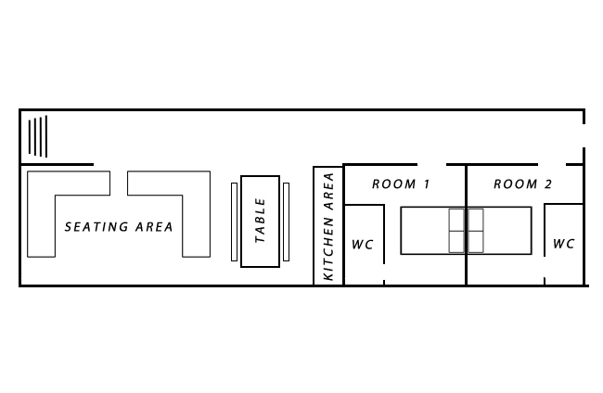

THE BARN – GROUND FLOOR
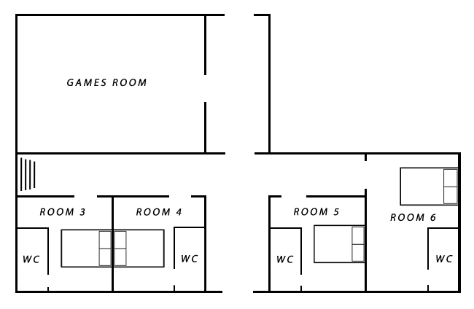

Harthill Hall

Nestling in 14 acres of Peak District National Park a position chosen for one of the earliest settlements in Derbyshire where in 1259 Sir Richard de Hartle was issued a Papal Bull by Alexander II allowing him to appoint his own chaplain. What was the original Hall House became a Chapel and was used as a place of worship until 1546.
Harthill Hall’s unique cottages and leisure facilities with the treasures of Chatsworth and Haddon Hall close by and just 3 miles from the historic market town of Bakewell make its central location ideal for either exploring the wonders of the Peak District or a tranquil holiday or short break.

Facilities:
Indoor Heated Swimming Pool + Sauna
1 hour - private use - per day is available to book daily on arrival to site don’t forget if its empty you can use it without booking as much as you like.
Therapy Treatment Rooms
best booked in advance 07738 463779

Inside The Barn:
100% Cotton Linen, Towels, Pool Towels, Bath Robes for adults, flip flops, LCD TV/ DVD Rural Wifi (1GB per device per day), STARTER supply of toilet rolls, washing up liquid and dishwasher tablets these are not meant to last your entire stay.

We can recommend the following outside caterers
zest4events.co.uk insyncdining.co.uk topnoshcaterers.co.uk

Directions to Harthill:
From M1 South & North Junction 28 - follow signs for Matlock A38, A61, A615, and A6 Matlock, Darley Dale and Rowsley. Approx 1 mile after Rowsley village left hand turn B5056 to Ashbourne. Follow this for approx 1 mile, looking for the road to turn left over a bridge and Harthill is 100 yards on right hand side.

Recommendations (all best booked well in advance)
Restaurants and takeaways
01629 812687 Piedaniel’s (French Restaurant) 01629 813764 Bamboo Cottage
01246 583259 Fischer’s (Michelin Star) 01629 653836 Druid Inn (dog friendly)
01629 582534 Maazi (Indian will deliver) 01629 690140 The Woodyard Bakewell
(dog friendly)
Taxis
Al’s 8 & 16 seaters 07866 661188 Andy 07853682348
Neil’s 07816 201746/07541541708 DJ’S 01629 650025

Beauty and Holistic Treatments
By Michelle 07738463779
michelle1942@live.co.uk

Holistic Treatments
Deep Tissue Full Body Massage 1hr £45
Deep Tissue Back Massage 35min £30
Aromatherapy Full Body Massage 1hr £50
Aromatherapy Back Massage 30min £35
Hot Stone Full Body Massage 1hr £45
Hot Stone Back Massage 30min £30
Reflexology 45min £40
Indian Head Massage 30min £30
Hopi Ear Candles 30min £30
Full body Exfoliation 30min £30
Full body Exfoliation & Full Body Massage 1hr 30min £65

Beauty Treatments
Classic Facial 45min £35
Collagen Anti-Ageing Facial 45min £40
Microdermabrasion Facial 30min £35
Microdermabrasion Facial 1hr £55

Inch Loss Body Wrap 1hr 15 min £40
Wrap + Pamper 1hr 15min £65
(Inch Loss Body Wrap + 1 of the following: Facial, Reflexology, Hopi Ear Candles)

Manicure and Pedicure
Opi - Mini Manicure / Pedicure 1hr £35
Opi - Luxury Manicure 45min £30
Opi - Luxury Pedicure 45min £30

Pamper Parties are available in the comfort and convenience of your own holiday cottage – organised by myself (and another therapist if needed). All treatments; 30mins at £30 each, are as follows:

Manicure/Pedicure Back Massage
Mini Facial Indian Head Massage
Spray Tan Hopi Ear Candles
Reflexology

Hot Tub Information

Hot Tubs and pools are very popular with our customers, they are great if you want to relax and they can be a highlight of your holiday however there are risks involved in providing this sort of facility.

- The water in the hot tub is checked each day DO’S AND DON’T’S

PLEASE FOLLOW INSTRUCTIONS BELOW TO TAKE OFF THE LID IT TAKES 2, DO NOT SIT/STAND ON THE LID.
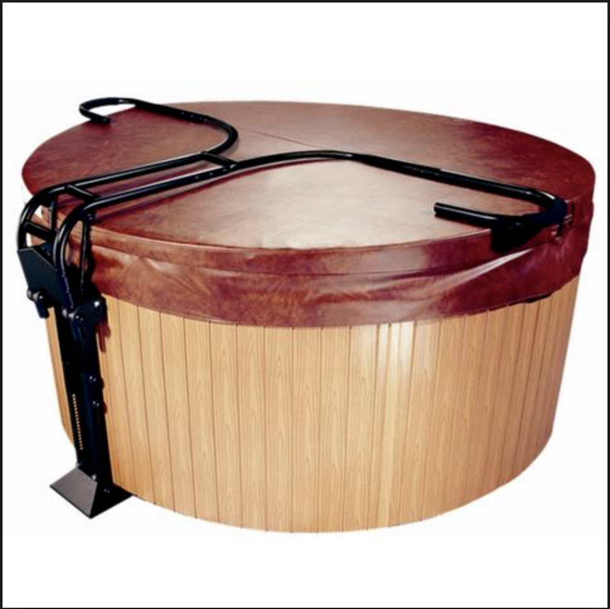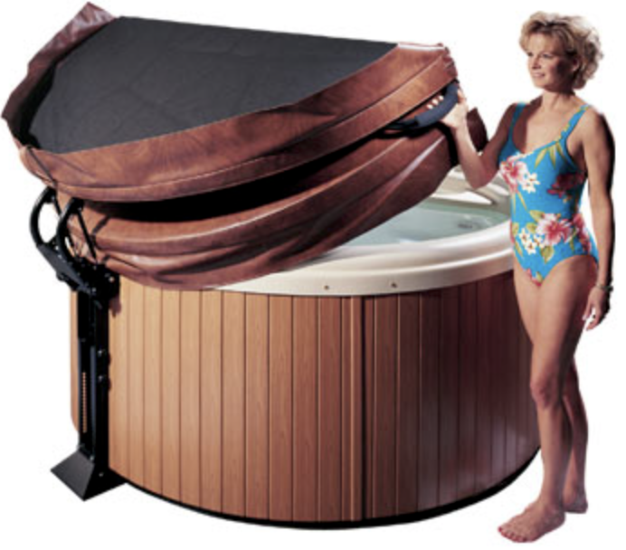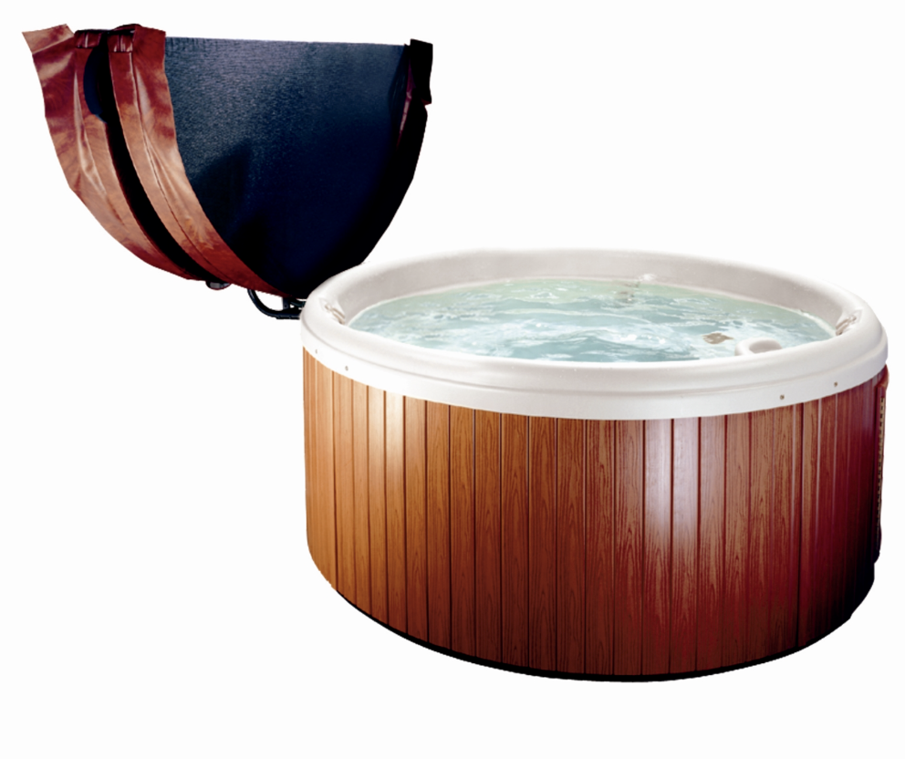

PLEASE ENSURE THE DIALS ARE RETURNED TO THE OFF-POSITION AS SHOW BELOW WHEN YOU HAVE FINISHED AND THE COVER IS REPLACED AS DIRECTED ABOVE

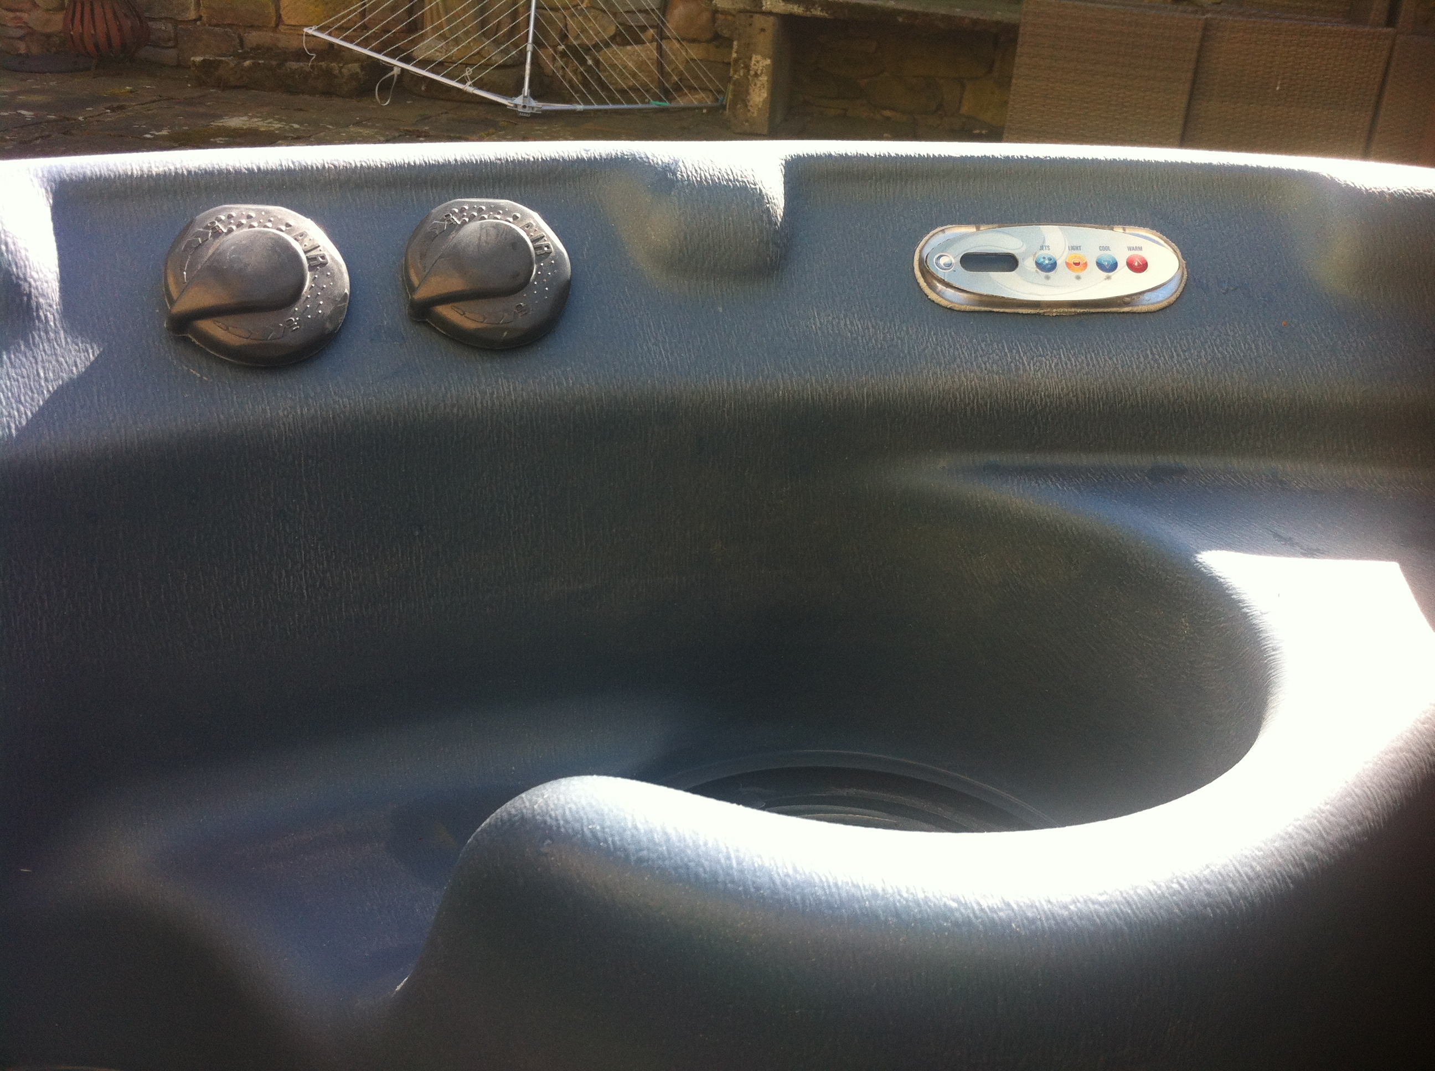

BELOW PHOTO CAUSED BY OVERFLOWING WATER - TREAT IT AS A BATH IN YOUR OWN HOME, IF YOU OVER OCCUPY IT THE WATER WILL SPILL OVER THE EDGE & WHEN YOU GET OUT THE WATER WILL BE UNDER THE FILTER/JET LEVELS THIS WILL DAMAGE THE MOTOR IF FOUND LIKE THIS THE HOT TUB WILL BE CONDEMMED AND WITHDRAWN FROM USE.
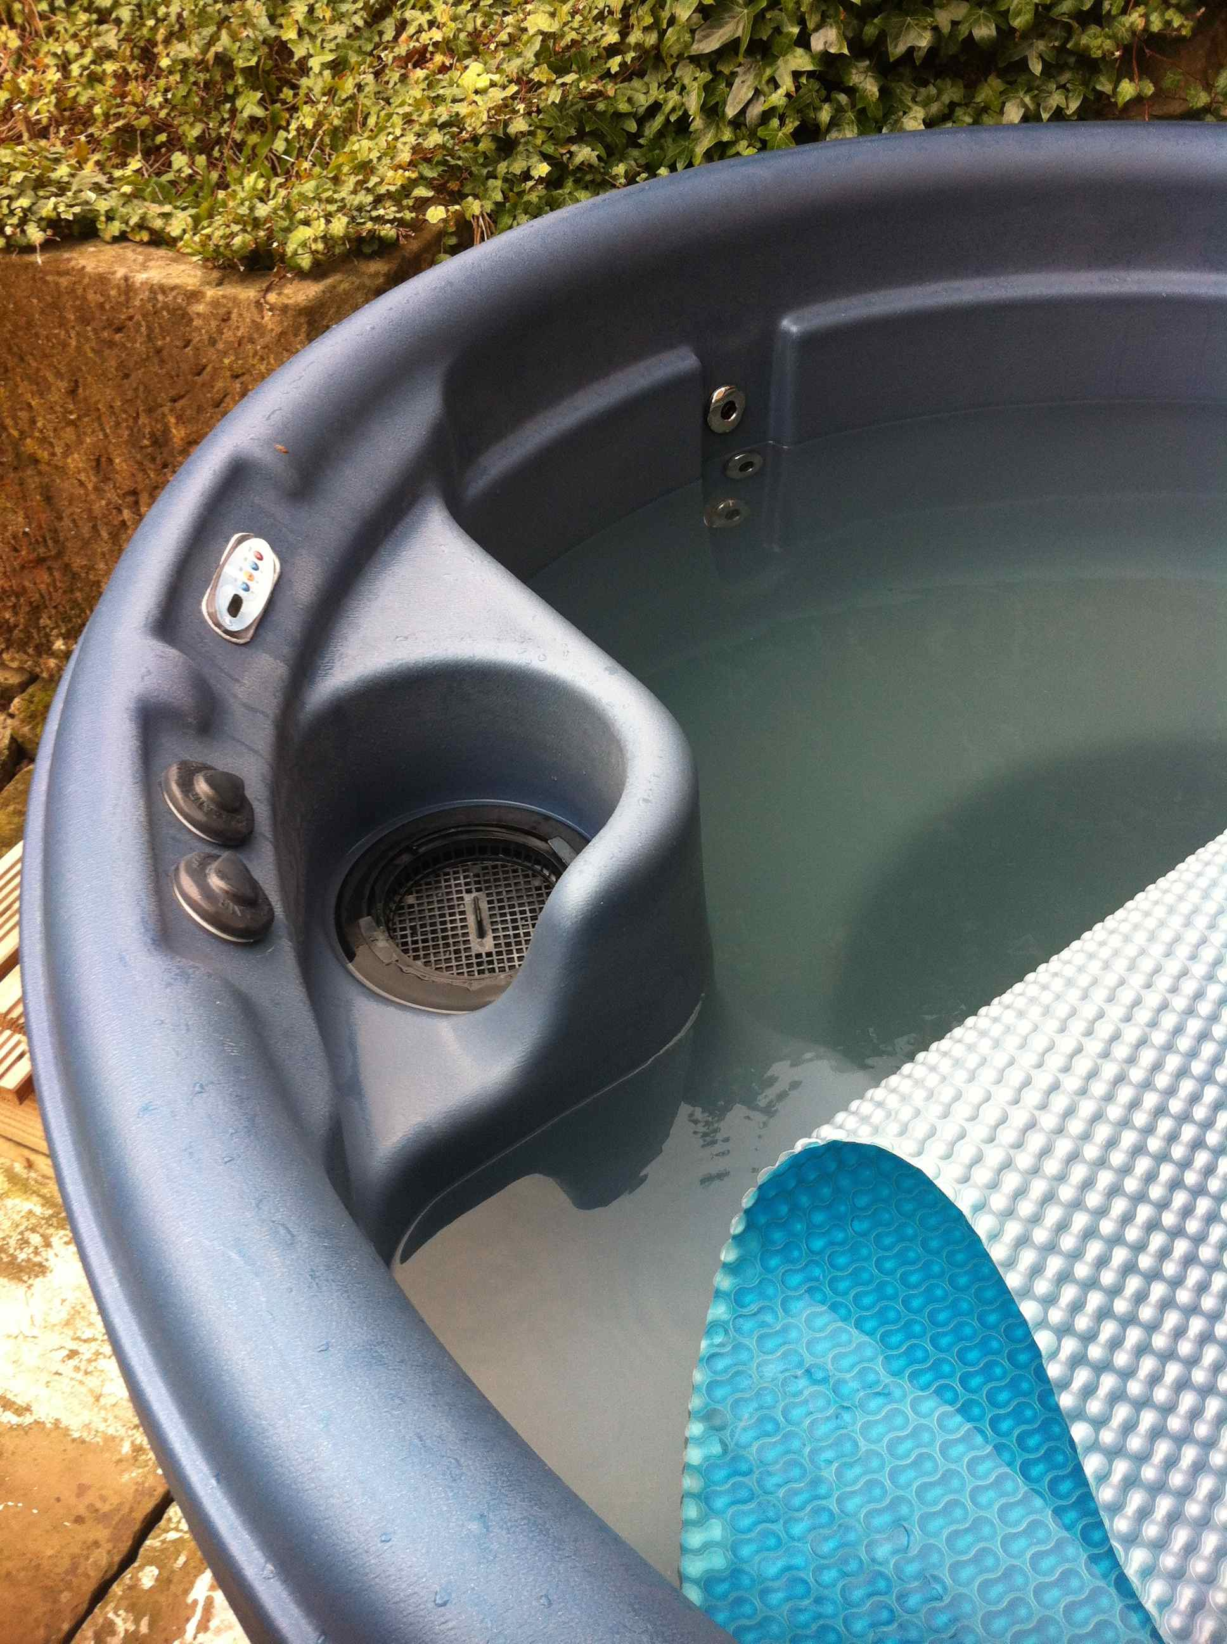

BELOW CAUSED BY FAKE TAN, MAKE UP AND COSMETICS
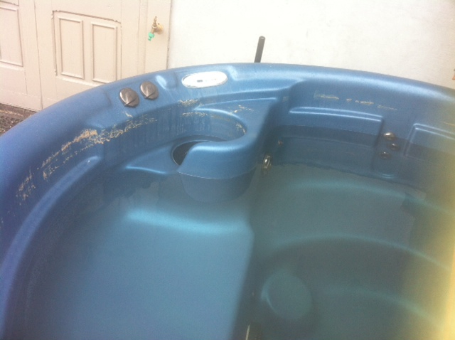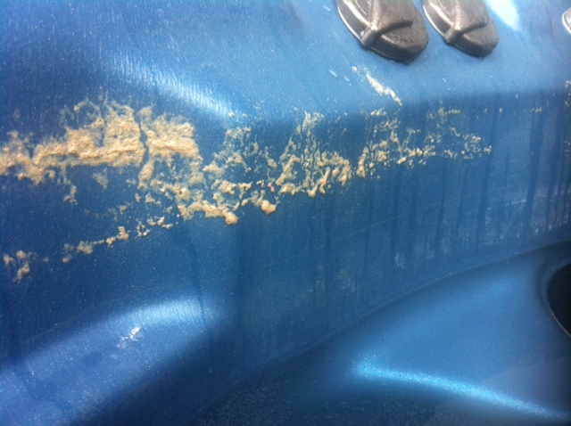 PTO
No Alcohol - the risks involved in using this facility whilst under the influence of Alcohol, prescription drugs or anything else likely to affect your judgment or the condition of your body, are too great for us to permit it’s use.

- Do not use the hot tub spa if you are pregnant or on any medication. Consult a doctor beforehand.

- Under no circumstances must glasses be taken into or near the hot tub. We reserve the right to withdraw the use immediately should there be any evidence that glassware has been used in or around the hot tub.

- Please keep noise levels down to an acceptable level whilst using the hot tub and be mindful that
there are neighbouring properties near, absolutely NO music outside.

Coloured towels are provided for hot tub/pool use; white towels are for indoor use.

WE CHECK YOUR HOT TUB DAILY SHOULD ANY OF THE ABOVE DO’S AND DON’T’S NOT BE ADHERED TO YOU MAY FIND A COMDEMNED NOTICE ISSUED AND THE FACILITY WITHDRAWN

GENERAL HOUSE RULES
- This is a non-smoking property and we kindly ask you not to smoke within the accommodation. Smokers please collect and dispose of cigarette butts in the bin when you leave.
- Please do not invite anyone back to the accommodation that would mean you exceed the maximum allowed for your property.
- Take good care of the property and leave it in a clean and tidy condition at the end of your stay, for those who have never stayed self-catering before this means, washing up and putting away any dishes or loading and turning on the, disposing of all foods open or closed, emptying bins and recycling to the bins situated just off the car park.
- If you should move furniture within the property during your stay, please can you move it back to its original place before you leave.
- Please can you check the property thoroughly before leaving to make sure you haven’t left any personal items behind, i.e. in drawer’s wardrobes, or phone charger in plug.
The organiser has paid a security deposit, if anything is broken or the property needs excessive cleaning, we will retain this and you will need to reimburse them.

We operate a zero tolerance on rowdy parties we are a family site and if we deem the behaviour from your properties inhabitants unacceptable your hire will be terminated immediately.
We ask that you are respectful of our other guests and neighbours so no outside music/noise or anything that can cause a disturbance after midnight.
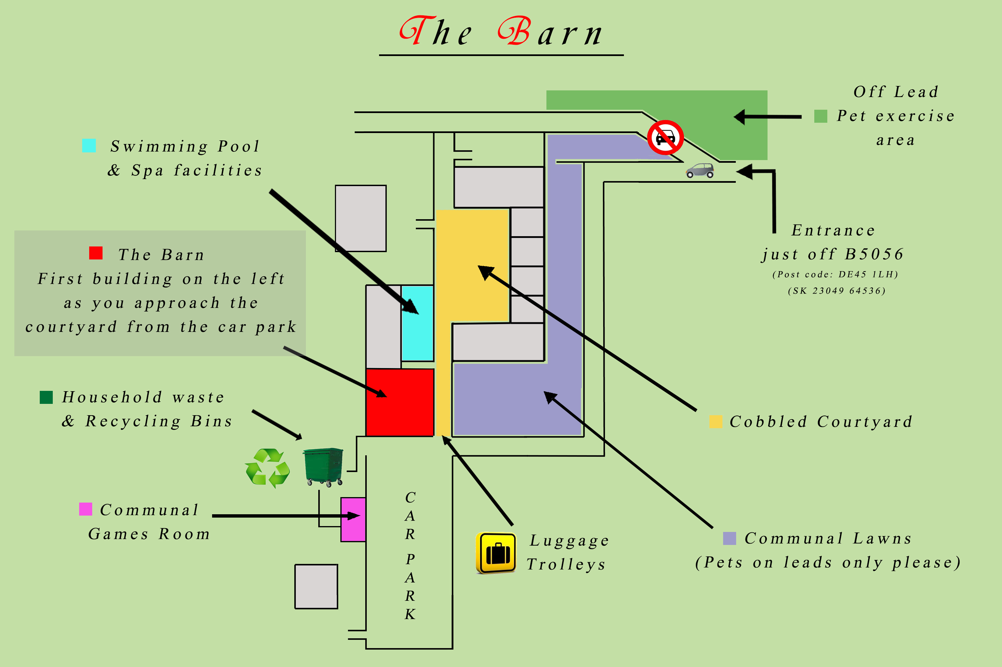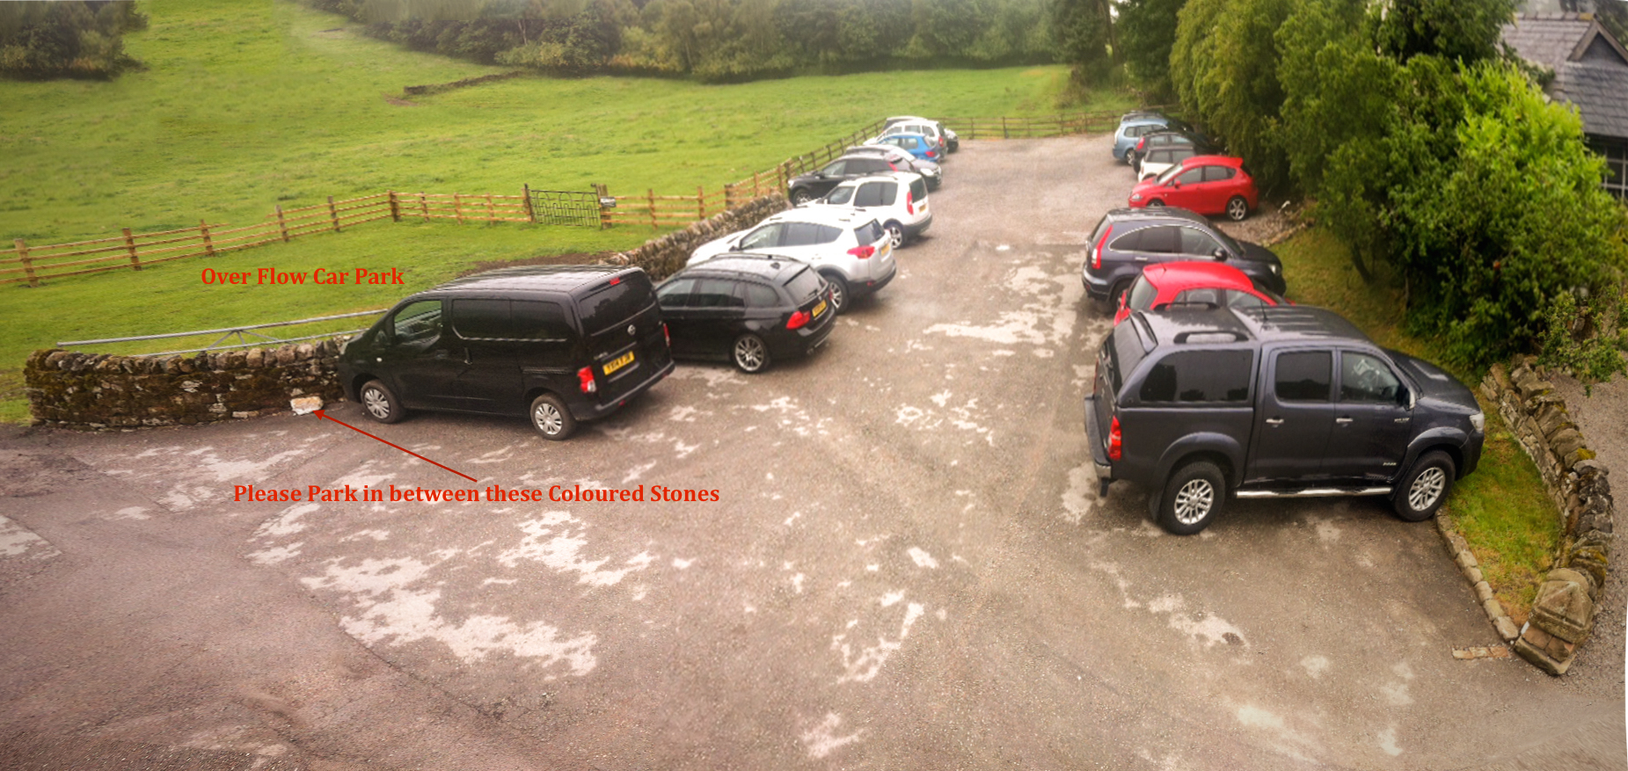

Dog Policy

Pre booked Dogs are most welcome at Harthill Hall.

A special off lead exercise area is available to use.
Please keep your dog on a lead at all times except in the allocated off lead area.
It’s your dog’s holiday too - do not leave him unattended in the property at any
time (unless he has his special box/crate). We do not allow dogs in bedrooms.
Please clear up any mess and deposit this in the skips situated in the car park.

