DERBYSHIRE MANOR HOUSE LTD

Thank you for choosing The Manor House at Harthill Hall. Please find below information regarding your booking including swimming pool and therapist’s bookings.

Security Bond Payment
£500 is payable by bank transfer please use your booking reference, surname and name of property as reference, this needs to be received no later than three working days prior to your arrival, please email to confirm this has been actioned along with the bank account details for the refund which will be issued within 7 working days excessive cleaning charges and significant breakages (not a broken wine glass or two) will be deducted if necessary.
Derbyshire Manor House Sort code 60-83-71 Account no 81598301
use reference booking name date of arrival eg Smith21012020
Key safe codes will only be sent on receipt of the email and payment.
Bedding Requirements
Email your requirements 14 days prior to arrival options below.
Pets
Up to 2 pets can be pre booked they should be under 25kg and not be on the UK Government Dangerous dog list, this includes pit bull types or pit bull type crosses.
Arrival and Departure
You are welcome to arrive from 4pm, we ask that you have removed all your belongings, empty your bins and vacate the Manor House fully no later than 10am.
Directions: https://goo.gl/maps/6nzzRx56encQDfYL6

I will be your contact for the duration of your stay, if possible please avoid any contact after 4pm daily unless it really cannot wait until the morning. If you are celebrating a special occasion, have any special requests or require any further information, please let me know by email beforehand.

We will be your contactless contacts for the duration of your stay, if we are unable to solve any issues in a contact free method (email/txt/whatsapp/facetime/video call) we will ask you all to fully vacate the property and leave the entrance clear before our arrival.
Kind regards
Lolly Miller (housekeeper) Email: housekeeping@derbyshirecountryhouses.com
Txt/WhatsApp/Facetime: 07703 126635
Steve Woodhead (general maintenance, repairs, hot tubs)
Email: repairs@derbyshirecountryhouses.com Txt/WhatsApp/Facetime: 07703 126635
The Manor House Harthill Hall Bakewell Derbyshire DE45 1LH
www.derbyshirecountryhouses.com

- Children’s Beds (under 8’s only) ONE / TWO / THREE
- Super king or twin room TWIN/DOUBLE
- Double sofa bed downstairs YES / NO
- Cots ONE / TWO / THREE
- High Chairs ONE / TWO / THREE
- 4 Fixed doubles NO OPTION
- 1 Fixed triple NO OPTION

Harthill Hall

Nestling in 14 acres of Peak District National Park a position chosen for one of the earliest settlements in Derbyshire where in 1259 Sir Richard de Hartle was issued a Papal Bull by Alexander II allowing him to appoint his own chaplain. What was the original Hall House became a Chapel and was used as a place of worship until 1546.
Harthill Hall’s unique cottages and leisure facilities with the treasures of Chatsworth and Haddon Hall close by and just 3 miles from the historic market town of Bakewell make its central location ideal for either exploring the wonders of the Peak District or a tranquil holiday or short break.

Facilities:
Indoor Heated Swimming Pool + Sauna
1 hour - private use - per day is available to book daily 24 hours in advance, more than 1 session booked of the same time will be cancelled CLICK HERE TO BOOK
Therapy Treatment Rooms CLOSED UNTIL FURTHER NOTICE

Inside The Manor House:
100% Cotton Linen, House Towels, Bath Robes for adults, flip flops, LCD TV/ DVD Rural Wifi (1GB per device per day), STARTER supply of toilet rolls, washing up liquid and dishwasher tablets these are not meant to last your entire stay will be supplied in sealed biodegradable bags.

We can recommend the following
Outside caterers
zest4events.co.uk insyncdining.co.uk topnoshcaterers.co.uk

Restaurants, Pubs and takeaways
01629 812687 Piedaniel’s (French Restaurant) 01629 813764 Bamboo Cottage
01246 583259 Fischer’s Baslow 01629 650363 Red Lion Birchover
01629 582858 Moja (Indian will deliver) 01629 690140 The Woodyard Bakewell
01629 636333 The Flying Childers Stanton

Taxis
Al’s 8 & 16 seaters 07866 661188 Andy 07853682348
Neil’s 07816 201746/07541541708 DJ’S 01629 650025

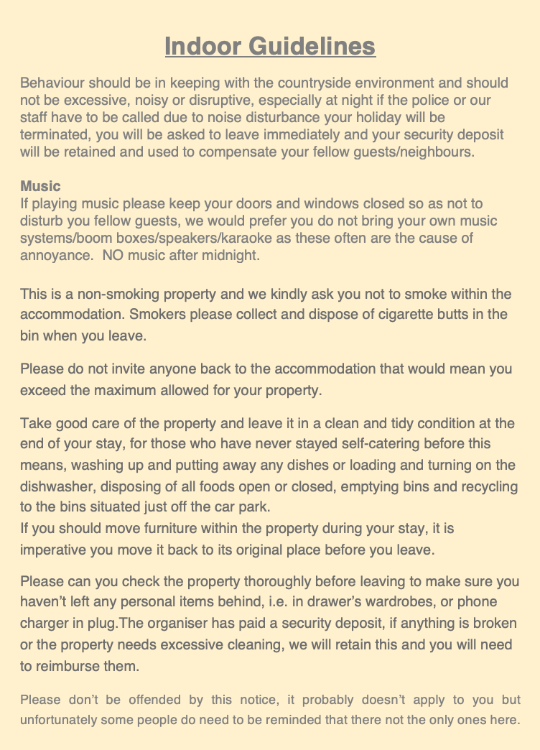

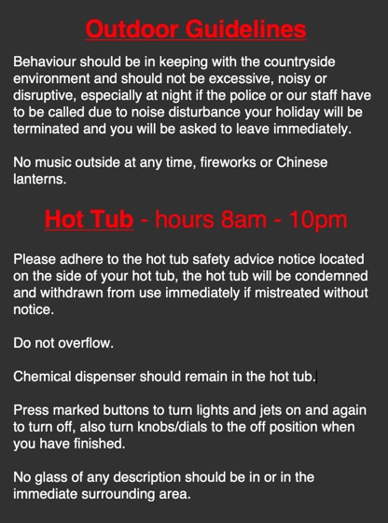

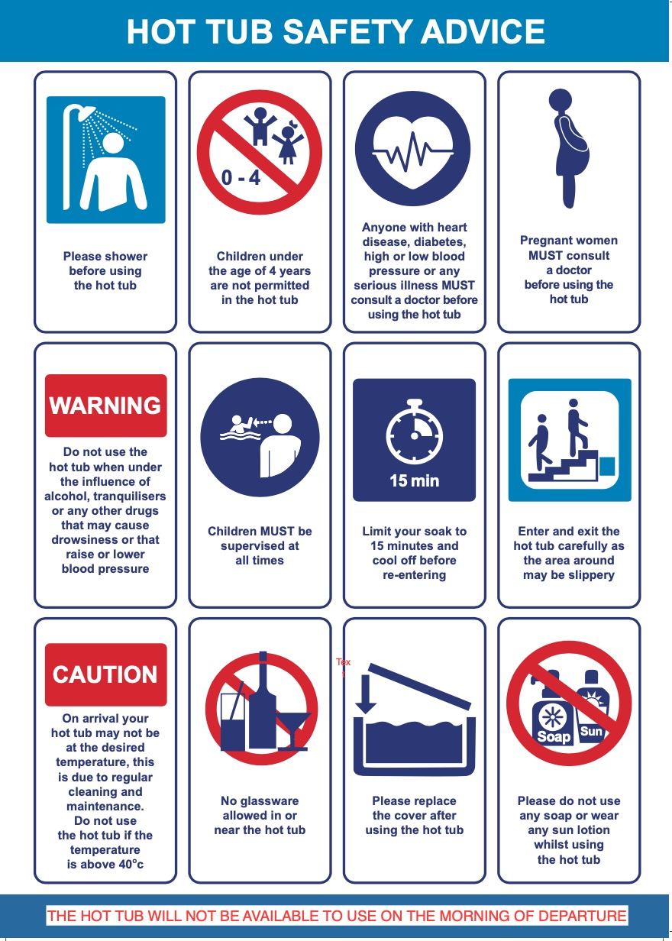
Beauty and Holistic Treatments
By Michelle 07738463779
michelle1942@live.co.uk Payment by cash/cheque/card

Holistic Treatments

Deep Tissue Full Body Massage 1hr £45
Deep Tissue Back Massage 35min £30
Aromatherapy Full Body Massage 1hr £50
Aromatherapy Back Massage 30min £35
Hot Stone Full Body Massage 1hr £45
Hot Stone Back Massage 30min £30
Reflexology 45min £40
Indian Head Massage 30min £30
Hopi Ear Candles 30min £30
Full body Exfoliation 30min £30
Full body Exfoliation & Full Body Massage 1hr 30min £65

Beauty Treatments

Classic Facial 45min £35
Collagen Anti-Ageing Facial 45min £40
Microdermabrasion Facial 30min £35
Microdermabrasion Facial 1hr £55
Inch Loss Body Wrap 1hr 15 min £40
Wrap + Pamper 1hr 15min £65
(Inch Loss Body Wrap + 1 of the following: Facial, Reflexology, Hopi Ear Candles)

Manicure and Pedicure
Opi - Mini Manicure / Pedicure 1hr £35
Opi - Luxury Manicure 45min £30
Opi – Luxury Pedicure 45min £30

Pamper Parties are available in the comfort and convenience of your own holiday cottage – organised by myself (and another therapist if needed). All treatments; 30mins at £30 each, are as follows:

Manicure/Pedicure Back Massage
Mini Facial Indian Head Massage
Spray Tan Hopi Ear Candles

